Paul Minniti
COSC 120
Lab #7
4-23-15

Lab report: I have finished all the tasks of the lab by my own. I have had no problem working out the questions. It took me approximately 3:30 hours/minutes to work on it.

Lab 11.1

Exercise 1:

[Source code ]

#include <iostream>
#include <iomanip>
#include <fstream>
using namespace std;

struct rectangle
{
double width;
double length;
double area;
double perm;
};

int main()
{
rectangle box;
cout << "Enter the length of a rectangle: ";
cin >> box.length;
cout << "Enther the width of a rectangle: ";
cin >> box.width;
cout << endl << endl;

box.area = box.length*box.width;
box.perm = box.length * 2 + box.width * 2;

cout << fixed << showpoint << setprecision(2);

cout << "The area of the rectangle is " << box.area << "." << endl;
cout << " The perimiter of the rectangle is" << box.perm << "." << endl;

if (box.length == box.width)
cout << "The rectangle is a square" << endl;

return 0;
}

[sample output]

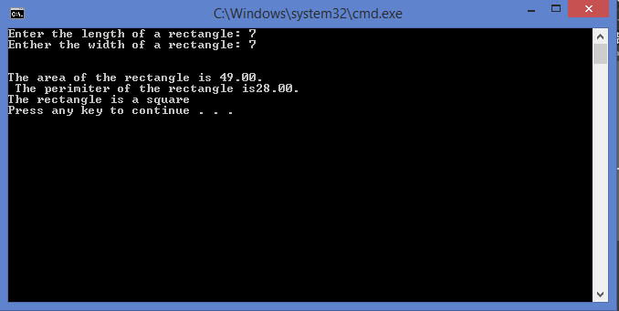

Lab 11.2

Exercise 1:

[Source code ]

#include <iostream>
#include <iomanip>
using namespace std;

struct taxpayer
{
char name[25];
long int social;
float taxrate;
float income;
float taxes;
};

int main()
{
taxpayer citizen1 = { "Tim McGuiness", 255871234, .35 };
taxpayer citizen2 = { "John Kane", 278990582, .29 };

cout << fixed << showpoint << setprecision(2);

cout << citizen1.name << " Please enter your income for this year: ";
cin >> citizen1.income;
citizen1.taxes = citizen1.income*citizen1.taxrate;

cout << "Name: " << citizen1.name << endl;
cout << "Social Security Number: " << citizen1.social << endl;

cout << "Taxes due for this year: $" << citizen1.taxes << endl << endl;

cout << citizen2.name << " Please enter your income for this year: ";
cin >> citizen2.income;
citizen2.taxes = citizen2.income*citizen2.taxrate;

cout << "Name: " << citizen2.name << endl;
cout << "Social Security Number: " << citizen2.social << endl;

cout << "Taxes due for this year: $" << citizen2.taxes << endl << endl;

return 0;
}

[sample output]

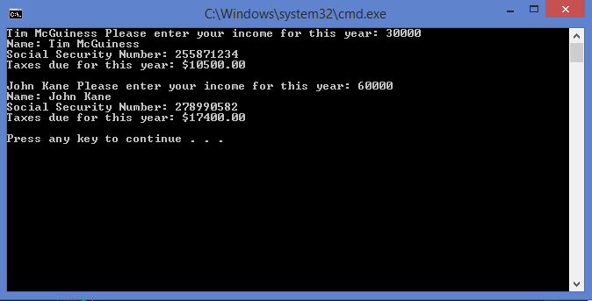

Lab 11.3

Exercise 1:

[Source code ]

#include <iostream>
#include <iomanip>
using namespace std;

struct taxpayer
{
float income;
float taxrate;
float taxes;
};

int main()
{
taxpayer citizen[5];

cout << fixed << showpoint << setprecision(2);

cout << "Please enter the annual income and tax rate for 5 tax payers: ";
cout << endl << endl << endl;

for (int count = 0; count < 5; count++)
{
cout << "Enter this years income for tax payer" << (count + 1);
cout << ": ";

cin >> citizen[count].income;

cout << "Enter the tax rate for tax payer #" << (count + 1);
cout << ": ";

cin >> citizen[count].taxrate;
citizen[count].taxes = citizen[count].income * citizen[count].taxrate;

cout << endl;
}
cout << "Taxes due for this year: " << endl << endl;

for (int index = 0; index < 5; index++)
{
cout << "Tax Payer #" << (index + 1) << ": " << "$ "
<< citizen[index].taxes << endl;

}

return 0;
}

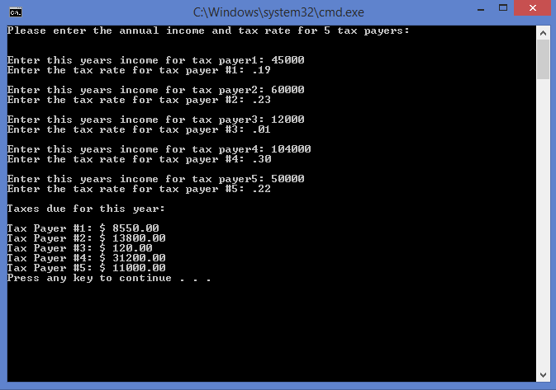

Lab 11.4

Exercise 1:

[Source code ]

#include <iostream>
#include <iomanip>
using namespace std;

struct dimensions
{
float length;
float width;
};

struct rectangle
{
float area;
float perm;
dimensions size;
};

int main()
{
rectangle box;

cout << "Enter the lenght of a rectangle: ";
cin >> box.size.length;

cout << "Enter the width of a rectangle: ";
cin >> box.size.width;

cout << endl << endl;
box.area = box.size.length * box.size.width;
box.perm = box.size.length * 2 + box.size.width * 2;

cout << fixed << showpoint << setprecision(2);
cout << "The area of the rectangle is " << box.area << endl;
cout << "The perimeter of the rectangle is" << box.perm << endl;

return 0;
}

